Great Barford Primary Academy
Behaviour and Discipline Policy
Introduction
Positive behaviour and attitudes enable children to make the most of school experiences and aid success in learning. In the context of our school, we would define positive behaviour as conduct that assists the school to fulfil its function which is to develop, as fully as possible, the abilities and social skills of all its pupils and to promote feelings of happiness and security for all.
It is our belief that our school should be a happy, calm and secure place for all, we pursue a positive approach to good behaviour, encouraging children to conduct themselves in a responsible, self-disciplined manner and to care about the needs and rights of others. Intrinsic to this approach is the additional belief that parents, carers, children and staff are all involved in a home/school partnership.
Aims
We aim to:
•Provide a calm, safe environment in which all pupils can achieve their very best.
• Raise children’s self esteem and help them to have confidence in themselves.
• Recognise that each child is an individual with their own needs.
• Help children to become aware of the needs of others.
• Promote respectful and thoughtful behaviour between all members of the school community.
• Promote independent self-discipline in our pupils and encourage them to accept responsibility for their own behaviour.
• Teach children the skills, values and attitudes needed to achieve and maintain positive behaviour.
• Encourage everyone to contribute to our codes of conduct.
• Develop an understanding of the important role everyone has to play in the smooth running of the school.
• Employ a consistent approach to behaviour throughout the school.
• Involve parents and carers in the good behaviour of their children and encourage them to support our code of conduct
• Develop an understanding of the importance of the school values in our lives and why they need adhering to.
• Positively involve pupils, staff, parents and carers in a common purpose and direction.

Codes of Conduct
At the beginning of each year, classes negotiate and verbalise a class code of conduct or charter. The children, with the help of their teacher, decide on positive ground rules that they believe will make for a happy, hardworking environment in their classroom and around the school. Once this code of conduct has been agreed, it is displayed in the classroom as a reminder and the children are expected to abide by it. We use a yoyo board in KS1 and 2 to support the children in reflecting on their behaviour in relation to the code or charter.
As well as the individual codes of conduct for each class the whole school follows a values curriculum that is delivered through assemblies and PSHE. This is integral to the school ethos. Our key values are Respect, Responsibility and Resilience. (See yearly plan further on in the policy)

Governors’ Responsibilities
The legal responsibility for the discipline of the school lies with the Governors who have delegated the day to day management to the headteacher, who may in turn delegate actions to the assistant headteacher and/or senior staff.
Staff Responsibilities
All staff have day-to-day responsibility for the discipline of the children in their classes. A caring classroom atmosphere helps to reinforce good behaviour and all staff are expected to be good role models for children. All staff share the responsibility for the sensible behaviour of the children in and around the school.
The senior lunchtime supervisor has responsibility for discipline during the lunchtime period overseen by the Headteacher. The supervisors liaise with the headteacher and assistant headteacher if necessary during the lunch break.
List of sanctions rules etc
Parents’/Carers’ Responsibilities
We encourage parents and carers to be aware of the school codes of conduct, expectations and we share the vision values and ethos at every opportunity. This supports the implementation of this behaviour and discipline policy. We look to our parents and carers to make their children aware of appropriate behaviour in all situations and to encourage in them independence and self-discipline. Above all we regard it the responsibility of the parents or carers as well as staff to foster good relations between home and school and to show an interest in what their child does here. (See home school agreement)
Children’s Responsibilities
Children are expected to follow our VALUES and codes of conduct in the school and classroom and show respect for the rights and needs of everybody in the school community and beyond, both adult and child. Good behaviour, politeness and good manners are insisted upon.
How We Encourage Good Behaviour

• Clear expectations of good behaviour are laid out and discussed, e.g. codes of conduct in the classroom.
• Anti-social behaviour is actively discouraged and mutual respect promoted through our values curriculum.
• Social awareness and understanding the needs and rights of others is taught as part of the curriculum, particularly in personal, social, health and citizenship education, religious education and collective worship.
• Each class has a reward system where children can earn points for the good of the whole class( Golden or Froggy time) • From YrR to Y6 class star awards are awarded weekly for specific work and improved effort. Each class also has a weekly values champion. These achievements are shared in our Friday celebration assembly. The nursery children receive daily recognition through the use of the “super learners” board by celebrating and sharing special work and good behaviour.
• Children are encouraged to take responsibility for their own actions and to make amends for any disruption or unhappiness they might have caused.
- Where appropriate, good behaviour is praised either privately or publicly. High standards of behaviour are set through the example of the adults and children in the school.
• Children are encouraged to help each other to behave correctly and to support those who have difficulty in doing so.
• In certain circumstances, behaviour plans may be set in place for specific children

We have a values programme that is delivered through our assembly programme and PSHE curriculum. The values are modelled by the staff and run through all that we do in our school.
Values 2 yearly programme
Autumn term 1 | Generosity
Autumn term 2 | Compassion
Spring term 1 | Courage
Spring term 2 | Forgiveness
Summer term 1 | Friendship
Summer term 2 | Respect

Autumn term 1 | Thankfulness
Autumn term 2 | Trust
Spring term 1 | Perseverance
Spring term 2 | Justice
Summer term 1 | Service
Summer term 2 | Truthfulness

How We Deal With Unacceptable Behaviour
• We talk calmly to the child who misbehaves, reminding that good behaviour is expected at all times. We reason with them and remind them of the school or class code of conduct and values.
• In the case of aggressive behaviour, we make it clear that behaviour that hurts, either physically or mentally or behaviour that irritates or offends to a marked degree is not acceptable.
• If necessary, we reassure the other child or children by making it clear to them that action is being taken to stop the aggressive behaviour.
• We give clear indications of the consequence of their action
• We offer children reflection or thinking time for a length of time appropriate to their age.

Depending on the severity of the unacceptable behaviour, differing courses of action or sanctions may be applied. There is no corporal punishment, no after school detention and no setting of lines. If unacceptable behaviour has occurred the staff member dealing with it will complete a Behaviour log sheet. For children with a behaviour plan an ongoing log will be kept.
Unacceptable behaviour can be divided into progressive stages as follows, because of the age of the children there may be different responses in nursery compared to Year 6.
Some children’s behaviour is beyond normal incentives and sanctions. These are usually children with emotional or physical needs who may have a condition, sometimes diagnosed, which affects their ability to respond in the expected way. Their needs may sometimes make them unhappy, angry or suffer from low self-esteem. It is often necessary to create for these children special, tailor-made programmes to include personal, achievable targets and a system of rewards and sanctions. In extreme cases of difficulty, special curriculum programmes and timetables may need to be set up for the child. Areas of behaviour that need improvement are identified and targeted in the child’s individual programme. Parents, Carers, headteacher, Assistant Head, SENCO, Teaching Assistants and outside agencies may be included in the programme if deemed necessary or helpful.

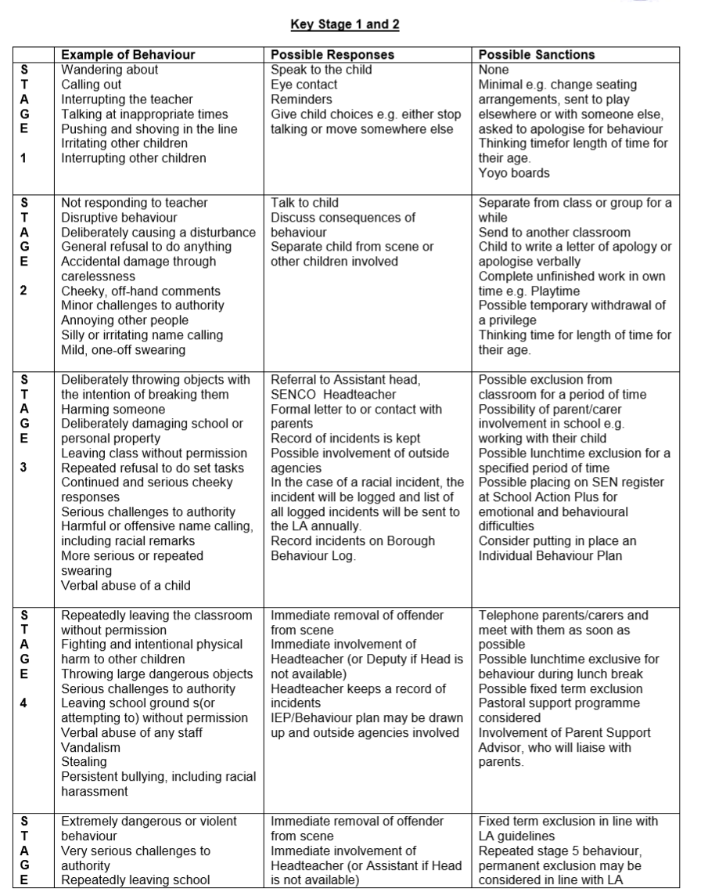
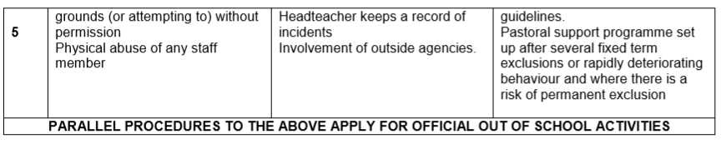

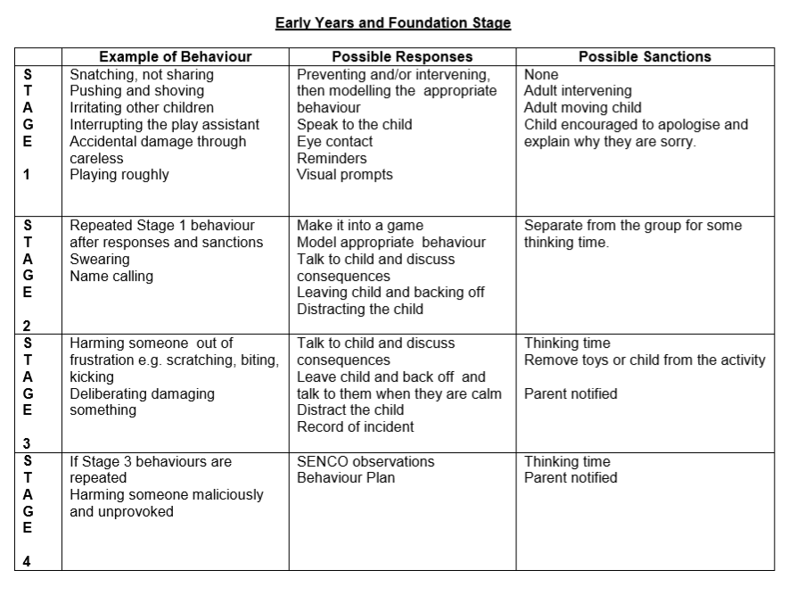

How We Support Staff in the Application of This Policy
All staff members have a communal responsibility for behaviour and discipline within the school and are expected to help and support each other, when needed, without reservation. We try to ensure that no member of staff is, or feels, isolated at any time.
If a child’s behaviour in class is such that the teacher wishes them to be removed from the classroom for a time, another teacher may receive the child in the first instances. If the behaviour is repeated, then help from the headteacher or assistant headteacher will be sought. In the cases of continued or extreme behaviour external advice may be sought.

Conclusion
We seek to provide a safe and happy environment in which children can learn. By following this policy, we expect to promote in children an understanding of the effect their behaviour has on other people and the importance of a strong value system and code of conduct in our society.
Policy Review
This policy will be reviewed in Nov 2019.

